*Sister* by Rudy Francisco

When I call you sister.

It means I broke their arm

When they touched you without

Your permission.

I’m sorry you had

To see me like that.

Finish the comic ↓--What is SpongeBob’s reaction to Gary’s gift?

**Horoscope What does yours say?:**

**Set a goal:**

**Libra (Sept. 23-Oct. 22)You have power struggles with someone. This might be someone at home or in the family; but it could be anyone. Be careful because the more you push, the greater you will increase their opposition to you.**

**Scorpio (Oct. 23-Nov. 21)The thing to watch out for this week is something going on behind the scenes that creates power struggles or obstacles for you. Best to put your cards on the table and be open about whatever troubles you. Be upfront, forthright and clear.**

**Sagittarius (Nov. 22-Dec. 21)Avoid a nasty standoff with a friend or a member of a group. Be your charming breezy, self.**

**Capricorn (Dec. 22-Jan. 19)Do yourself a favour and steer clear of nasty confrontations with parents, bosses, teachers, especially at the beginning of the week. You won't win if you wade into an argument. Timing is everything. You have to know when to hold and when to fold.**

**Aquarius (Jan. 20-Feb. 18)This week you might get carried away and become involved in an argument about politics, racial issues or religious matters. Don't do this. Not this week. Stand back and don't get involved in contentious subjects because the result will be nasty. Find a safe space and make it yours for the time being.**

**Pisces (Feb. 19-March 20) Now is the time to make your pitch or ask for a favor or do what you can to advance your agenda/plans for success**

**Aries (March 21-April 19)Be patient with partners and close friends, especially at the beginning of the week because you might encounter a standoff.**

**Taurus (April 20-May 20)At the beginning of the week, you will encounter difficulties with someone, probably on the job; however, these obstacles might also relate to a pet or something to do with your health.**

**Gemini (May 21-June 20)Give yourself extra time this week so that you have some wiggle room to cope with the unexpected. Be smart!**

**Cancer (June 21-July 22)Look for ways to make your workstation more attractive. Expect praise and maybe a raise.**

**Leo (July 23-Aug. 22)You know what you want to achieve; however, someone will block you. Ideally, channel this same energy into changing your daily environment in a creative way that pleases you. This is your winning choice.**

**Virgo (Aug. 23-Sept. 22)Make sure you are on the up and up because anything that is ruthless or underhanded will backfire. Continue with plans to entertain at home and make where you live more attractive.**

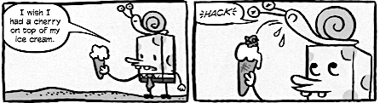

Create a sentence/phrase using the word “Sister”—start with creating a sentence phrase that begins with a word beginning with the letter S.

S

I

S

T

E

R

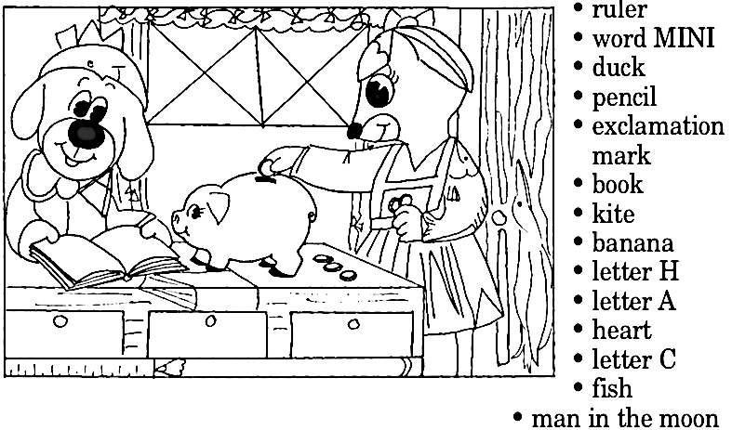

*Sis* by: ____________ **FILL IN THE BLANK**

If I hear someone say, “Hey Sis”

I’ll assume their talking to

__________________________________.

A sister to me is someone that

__________________________________.

I remember I felt like I was

Dismissed by a sis once

That didn’t get me cuz

__________________________________.

Sisters gotta ________________________.

Sisters need ________________________.

Only time I know to pass on a sis is

______________________________.

Just remember to ___________________.

Cuz _______________________________.